Experiment no.: 2

Aim: Design a mobile app for media player using user interface components.

Objective : To learn about diffrent user interface components like button ,textview , scrollbar, etc

Theory:

A Button is a Push-button which can be pressed, or clicked, by the user to perform an action.

Button
Button Attributes
Following are the important attributes related to Button control. You can check Android official documentation for complete list of attributes and related methods which you can use to change these attributes are run time.

Inherited from android.widget.TextView Class −

Sr.No Attribute & Description
1
android:autoText

If set, specifies that this TextView has a textual input method and automatically corrects some common spelling errors.

2
android:drawableBottom

This is the drawable to be drawn below the text.

3
android:drawableRight

This is the drawable to be drawn to the right of the text.

4
android:editable

If set, specifies that this TextView has an input method.

5
android:text

This is the Text to display.

Android SeekBar is a kind of ProgressBar with draggable thumb. The end user can drag the thum left and right to move the progress of song, file download etc.

The SeekBar.OnSeekBarChangeListener interface provides methods to perform even handling for seek bar.

Android SeekBar and RatingBar classes are the sub classes of AbsSeekBar.

Code:
package com.example.robpercival.sounddemo;

import android.app.Activity;
import android.content.Context;
import android.os.Bundle;
import android.util.Log;
import android.view.Menu;
import android.view.MenuItem;
import android.media.MediaPlayer;
import android.view.View;
import android.widget.SeekBar;
import android.widget.SeekBar.OnSeekBarChangeListener;
import android.media.AudioManager;

import java.util.Timer;
import java.util.TimerTask;

public class MainActivity extends Activity {

MediaPlayer mplayer;
AudioManager audioManager;

public void playAudio(View view) {

mplayer.start();

}

public void pauseAudio(View view) {

mplayer.pause();

}

@Override
protected void onCreate(Bundle savedInstanceState) {
super.onCreate(savedInstanceState);
setContentView(R.layout.activity_main);

mplayer = MediaPlayer.create(this, R.raw.laugh);

audioManager = (AudioManager)getSystemService(Context.AUDIO_SERVICE);
int maxVolume = audioManager.getStreamMaxVolume(AudioManager.STREAM_MUSIC);
int curVolume = audioManager.getStreamVolume(AudioManager.STREAM_MUSIC);

SeekBar volumeControl = (SeekBar)findViewById(R.id.seekBar);
volumeControl.setMax(maxVolume);
volumeControl.setProgress(curVolume);

volumeControl.setOnSeekBarChangeListener(new OnSeekBarChangeListener() {

@Override
public void onStartTrackingTouch(SeekBar seekBar) {

}

@Override
public void onStopTrackingTouch(SeekBar seekBar) {

}

@Override
public void onProgressChanged(SeekBar seekBar, int progress, boolean fromUser) {

audioManager.setStreamVolume(AudioManager.STREAM_MUSIC, progress, 0);

}

});

final SeekBar scrubber = (SeekBar) findViewById(R.id.scrubber);
scrubber.setMax(mplayer.getDuration());

new Timer().scheduleAtFixedRate(new TimerTask() {
@Override
public void run() {
scrubber.setProgress(mplayer.getCurrentPosition());
}
}, 0, 100);

scrubber.setOnSeekBarChangeListener(new OnSeekBarChangeListener() {
@Override
public void onProgressChanged(SeekBar seekBar, int progress, boolean fromUser) {

mplayer.seekTo(progress);

}

@Override
public void onStartTrackingTouch(SeekBar seekBar) {

}

@Override
public void onStopTrackingTouch(SeekBar seekBar) {

}
});

}

@Override
public boolean onCreateOptionsMenu(Menu menu) {
// Inflate the menu; this adds items to the action bar if it is present.
getMenuInflater().inflate(R.menu.menu_main, menu);
return true;
}

@Override
public boolean onOptionsItemSelected(MenuItem item) {
// Handle action bar item clicks here. The action bar will
// automatically handle clicks on the Home/Up button, so long
// as you specify a parent activity in AndroidManifest.xml.
int id = item.getItemId();

//noinspection SimplifiableIfStatement
if (id == R.id.action_settings) {
return true;
}

return super.onOptionsItemSelected(item);
}
}

OutPut :
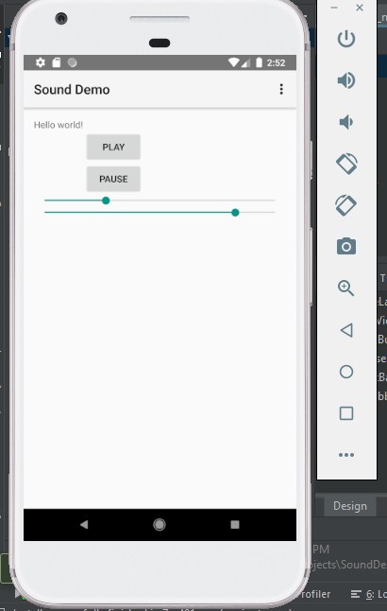

Conclusion: We succesfully developed the Music Player app for android.

